Abram Denzlinger

November 28, 2025

9.2 - APIs

### Assignment Step 4 - Tutorial

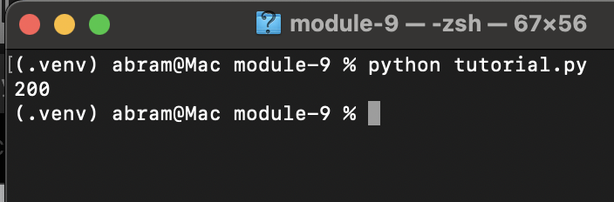

### Assignment Step 5 - Tutorial

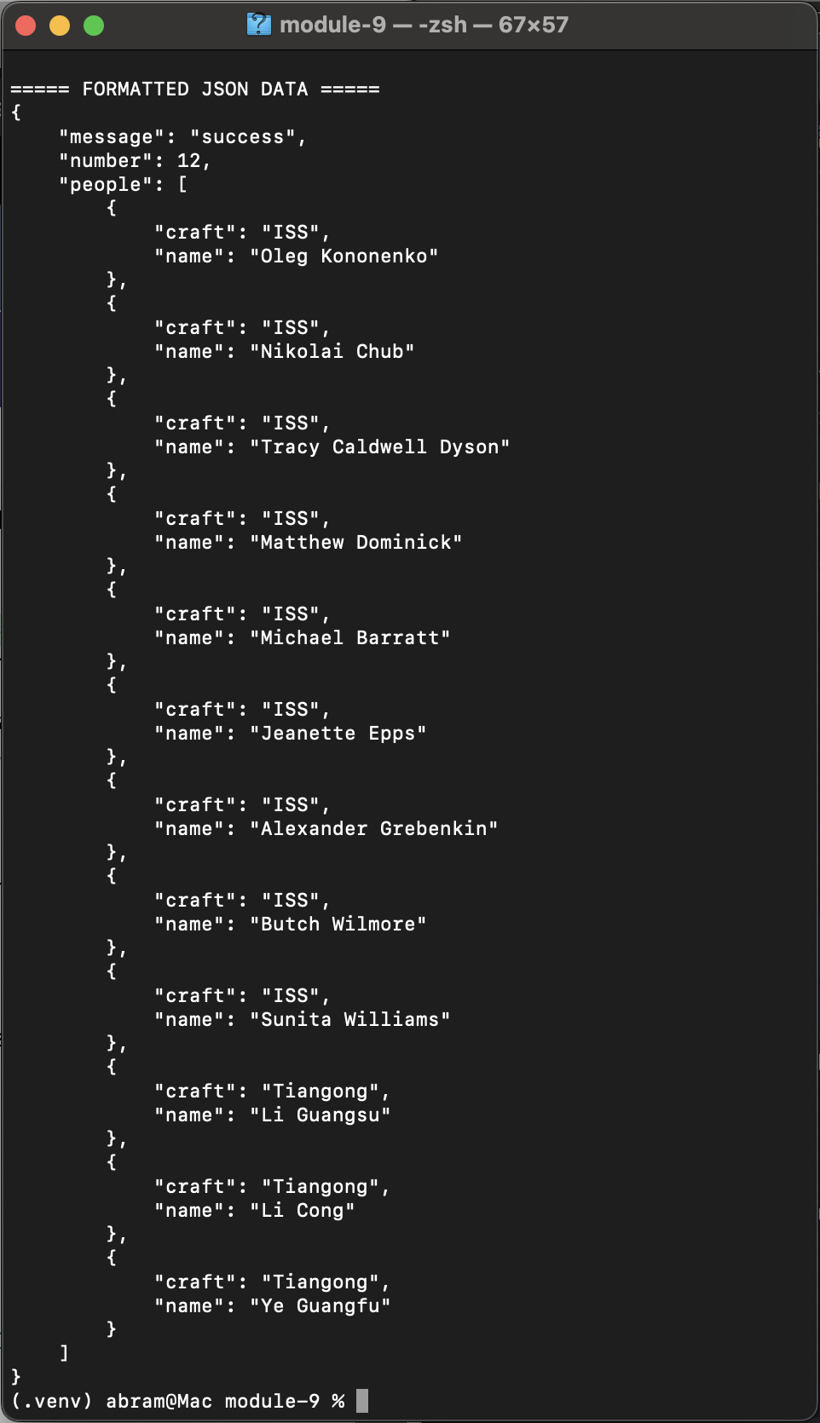

### Assignment Step 6 - Program with API of Choice

Page 1 of output

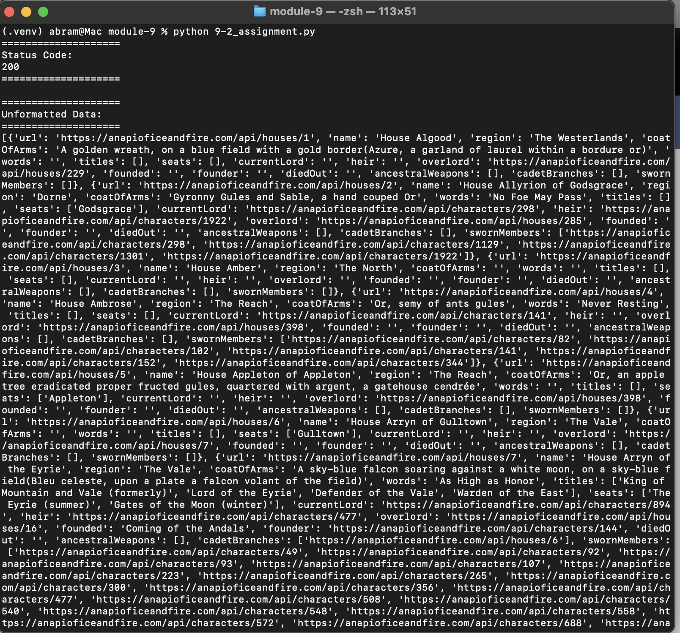

Page 2 of output:

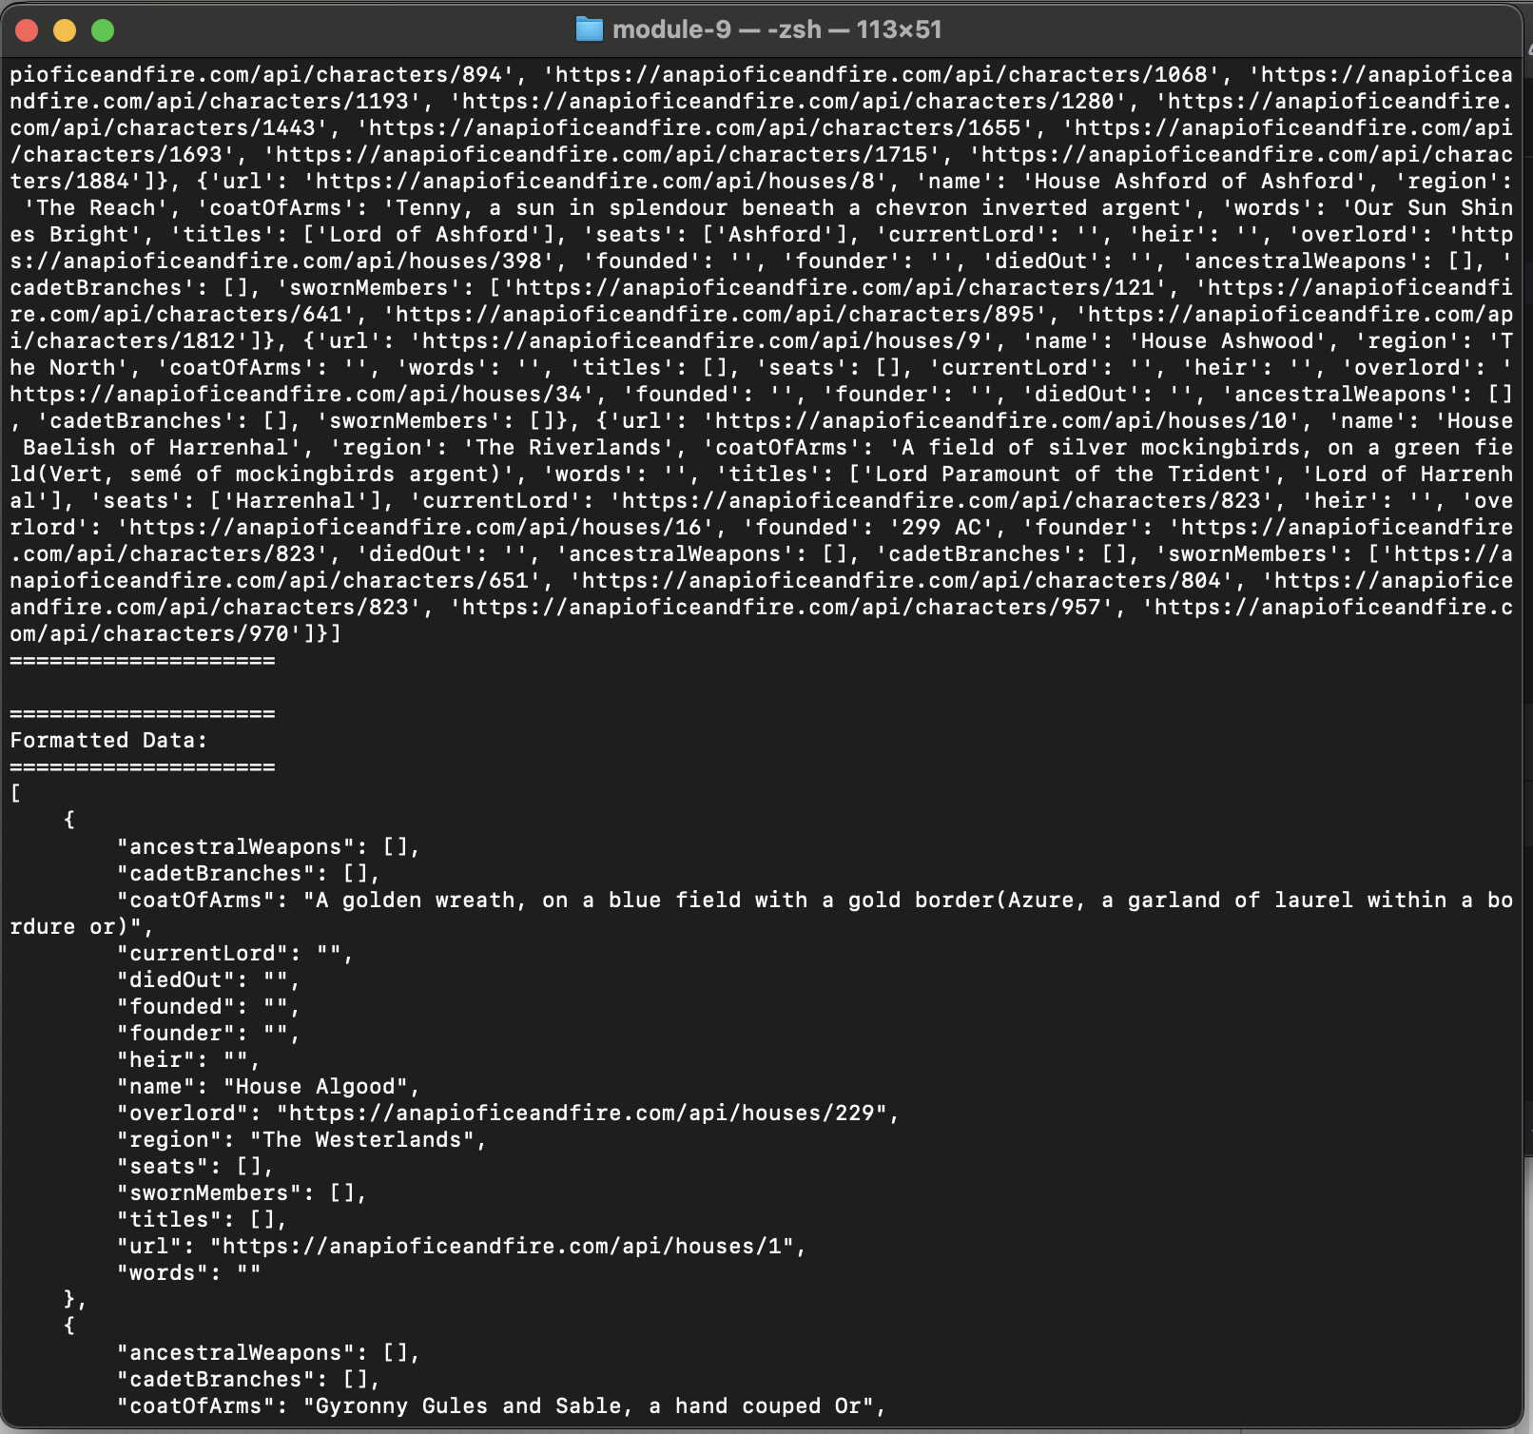

Page 3 of output:

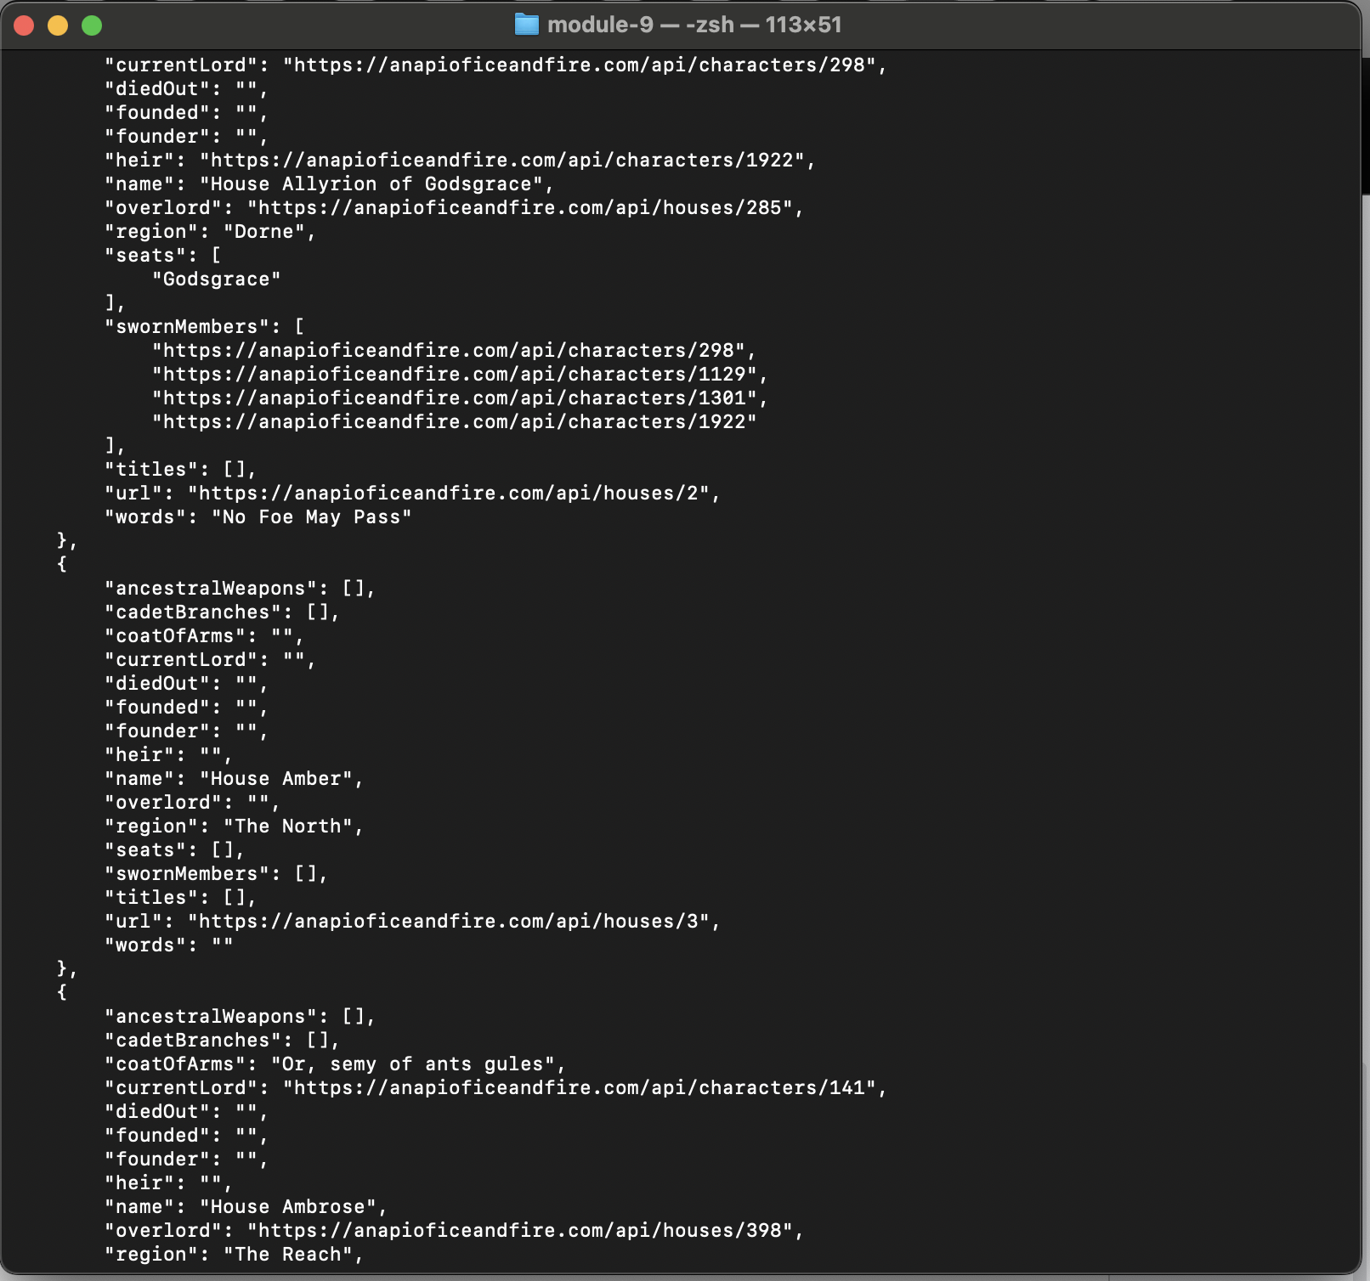

Page 4 of output:

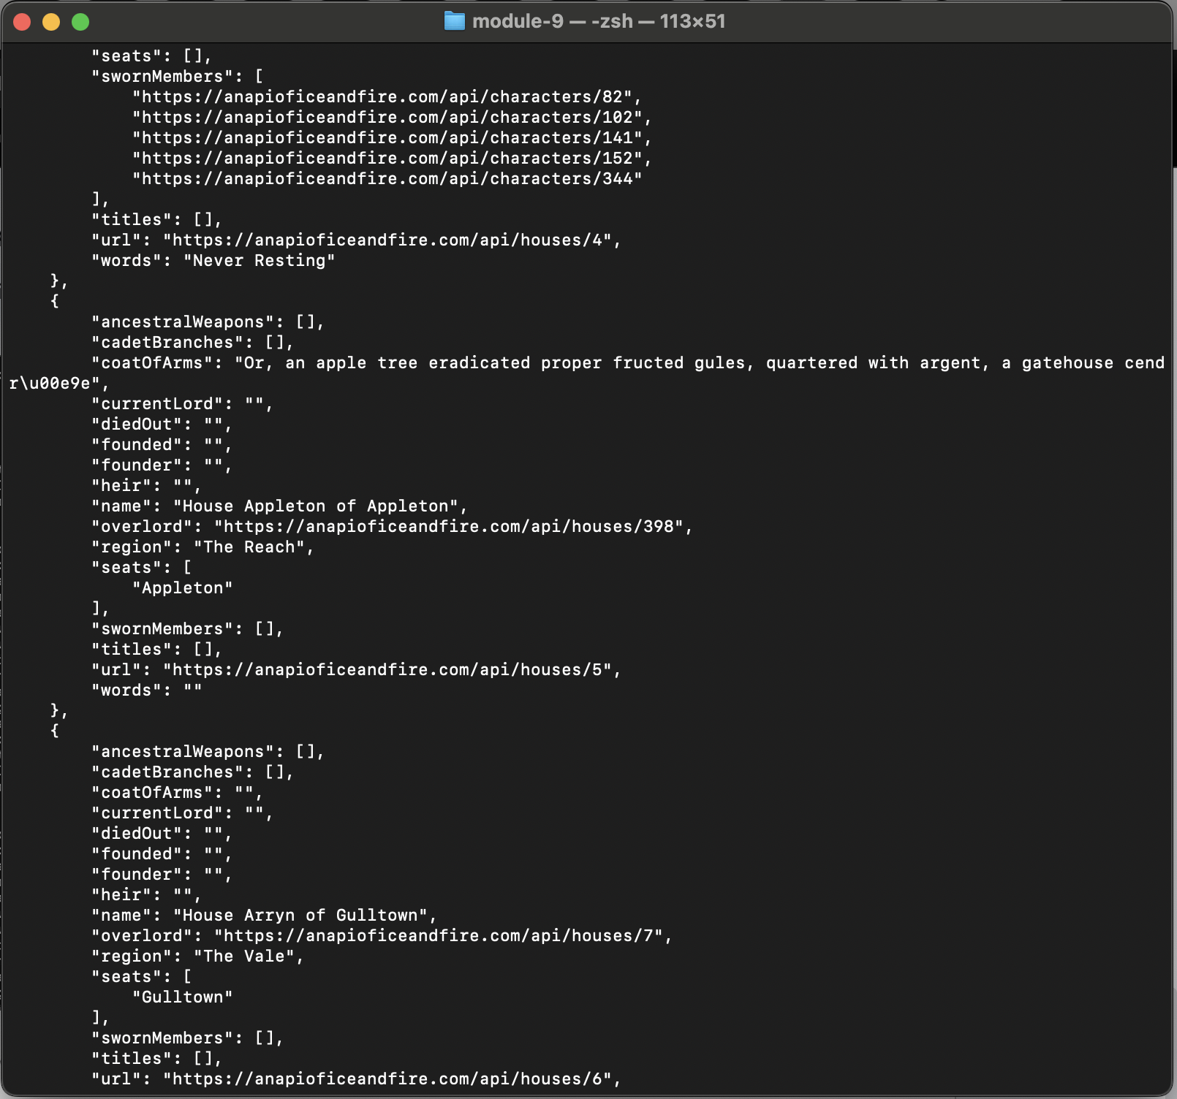

Page 5 of output:

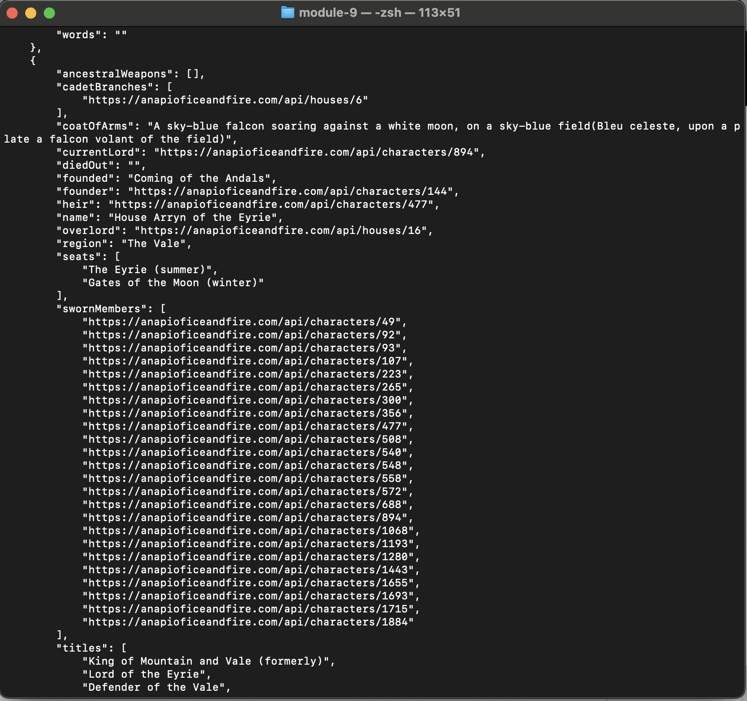

Page 6 of output:

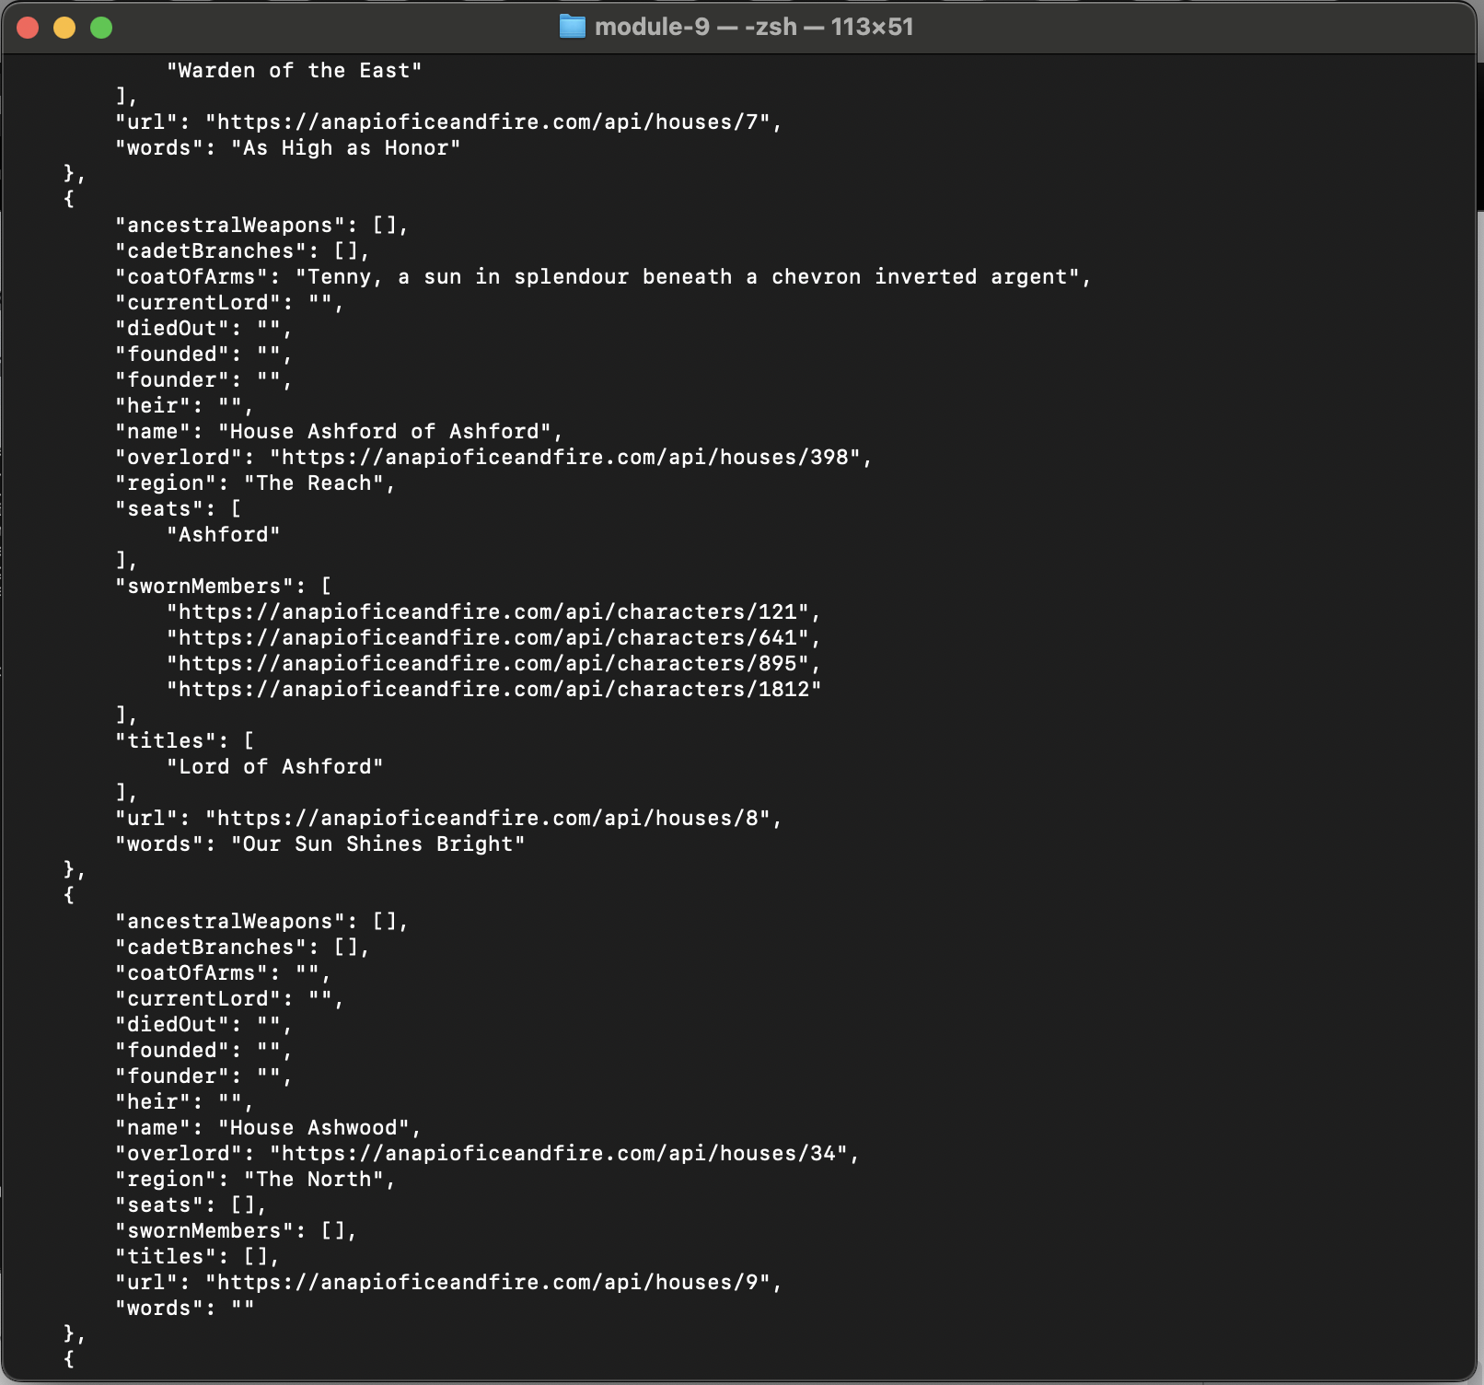

Page 7 of output:

